Zillow’s Home Value Prediction

**Background & Objective**

Zillow’s Zestimate is a properly home value prediction. The objective of this project is to predict the logerror which is the difference between the Zestimate and the actual sales price of homes, trying to improve Zestimate to advance prediction accuracy.

**Dataset and Methodology**

The dataset is offered by Kaggle. There is a training dataset with actual log error and 57 features with lots of missing value for 2985217 properties. We explored the log error (target value) to ensure the training data was normally distributed. After that, we imputed data and build the model.

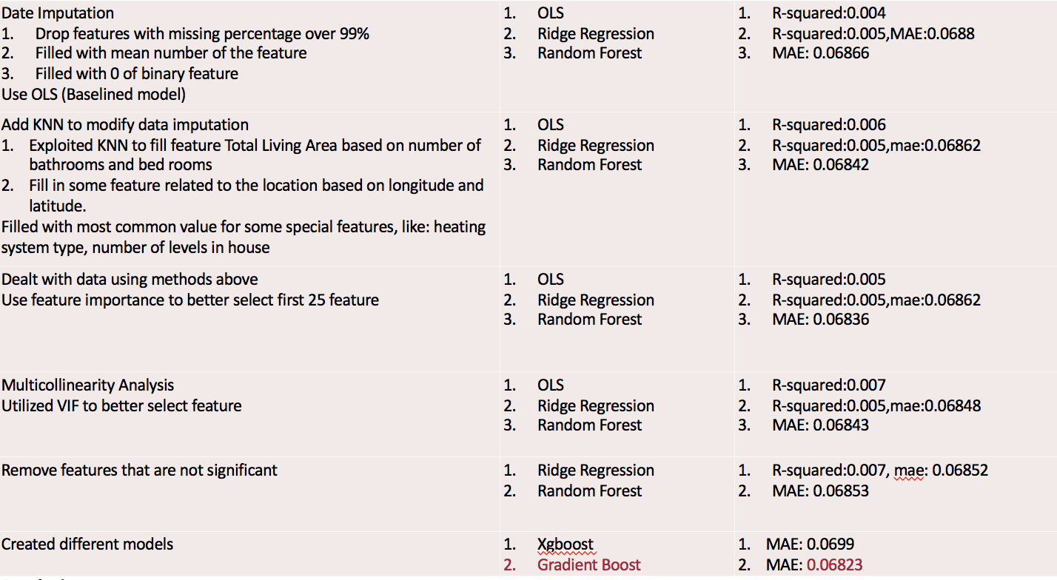

**Result and application**

The lowest MAE reaches 0.06823 with Gradient Boost. It is going to be helpful for property value prediction. We believe if Zestimate uses our model to predict the house price, it will be more accurate. It should be useful for both company and customers.